Super Duper Bowling GDD

Version History

Version 2.0

(-) = removed  
(+) = added

(≠) = Modified

(≠) Platform, Theme / Mood & Core Aesthetic.

(≠) Setting (changed to be more accurate to the new vision of the game)

(-) Boost Pads from Gameplay

(≠) Platforms & Movement in Gameplay

(+) Backstory

(+) Controls

(+) Sound references and styles

(≠) Parkour

(+) Constraints

(+) Top down level map

(+) Feedback

# Overview

|  |  |
| --- | --- |
| **Genre** | Platformer |
| **Platform** | PC + Mac |
| **Point of View** | First Person |
| **Theme / Mood** | Super Duper People Bowling |
| **Core Aesthetic** | Bowling alley |
| **Target Audience** | Young Boys |

# Setting

The game will be set inside of a bowling alley, meaning most of the platforms will be made of the alley’s wood. Everything in the game will have some resemblance with items in a bowling alley.

# Gameplay

The gameplay occurs on a straight platform that contains all the pins required to complete the level (10). The player must knock down pins by running into them.

As the player moves throughout the level, they can keep their momentum with wall running and sliding to lower their time.

Provided wall running, is implemented, the player will go straight across the wall and keep all speed. When jumping from the wall, all momentum is moved in the direction the player is facing, and the player will gain a small amount of height.

The more basic movement will be easy to use, but difficult to master. There will be normal movement keys (WASD & Space) as well as sliding, which will keep speed for a certain amount of time before starting to fall off.

# **Mechanics**

## Movement

The movement will be smooth and easy to control, changing direction very quickly to where the player wants to go. Normal WASD movement will be the slowest kind, but also the easiest.

Pin flying

The pins will fly away after being hit by the player

# **Parkour**

Parkour will be much faster than the average WASD movement, and it will only get faster the more parkour you do. The main Parkour abilities will be sliding, wall climbing, and wall running. Wall climbing will be the only one that slows the player down, as it requires the player to look at the wall for vertical movement. Sliding will conserve momentum better than walking, and wall running will gain momentum.

### Enemies

Enemies will be relatively stationary in comparison to the rest of the level to accommodate for the difficulty of moving. This will help the player guess where the enemy will be and hit them.

# **Risks and constraints.**

We have added a lot of features into this game, some (such as wall running) are very complex, and need a lot of time to implement them well. We have chosen to take a risk by not focusing on some of the larger things, so that we can complete the core gameplay loop first. We also have the constraint of not having much time, since we have slightly less than half a year to complete this, and also lack man power being a group of 3 that are relatively new to everything.

# **Controls**

WASD / space = basic movements & jump

Space with wall in front = wall climb

A/D + space with wall beside = wall run

# Mood Board & Colour Palette

Outer arena and stadium: Lime/Pink

Level and player interactable platforms: Purple/Yellow

# Maps and difficulty

There will be approximately 6 maps. The maps will all look similar and have a similar style, though this will be expanded upon if time is allocated.

The maps technical requirements will increase as the player continues through the game.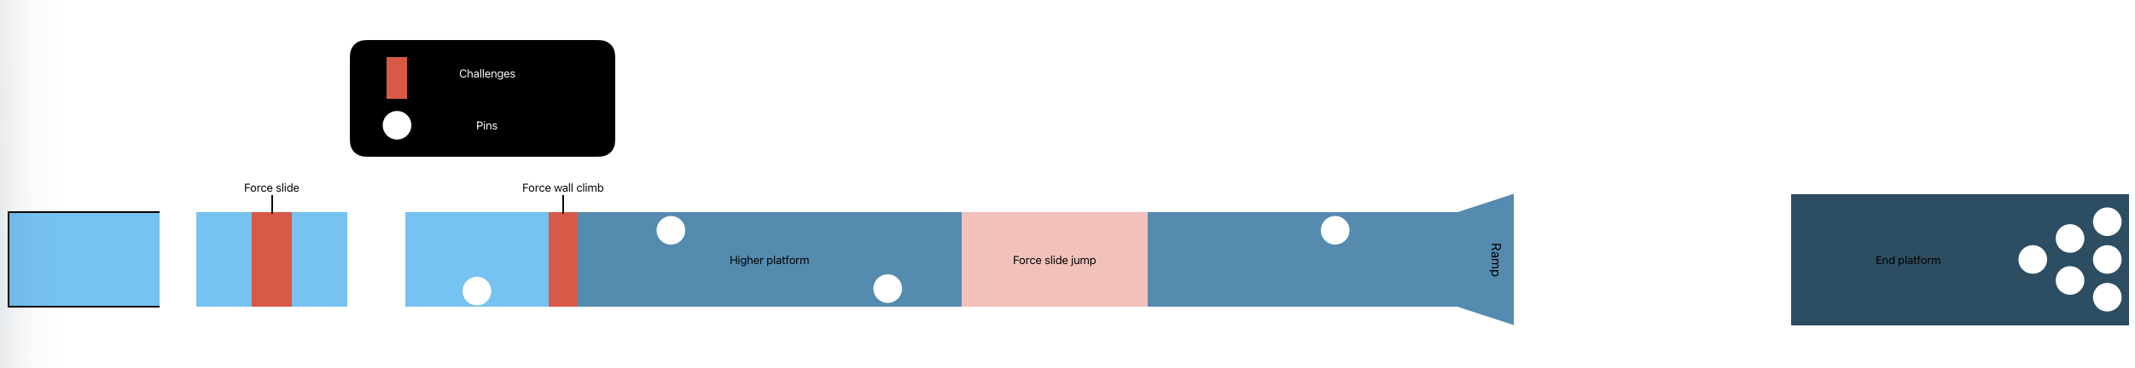

# Sound References and Styles

The music style of this game can range from slow calming in the menus, and chaotic and fast paced while in-game, all while keeping a light-hearted tone with a mix of some acoustic instruments and mostly electronic instruments.

The music is inspired by music from Fall Guys, as it depicts a really funky nature of the game. We believe this music to fit our game quite well.

The game is styled after a bowling alley, and after however you could make it happen, the lanes have been reshaped into parkour challenges.

# Backstory

The main character, Malcom Baller, has always been baller at Super Bowling. Eventually though, it became a professional sport, the Super Bowling League (SBL). Malcom decided to dominate the sport. The game follows Malcom on his journey of being the best, with record breaking victory after record breaking victory, Malcom defeats all his opponents in time, accuracy, and unmatched style.

When the player completes all the levels, there will either be a "cutscene" or just a simple trophy on the home screen. It's unlikely this lore will be conveyed to the player, as it doesn’t add much to the game.

# Feedback

We didn’t receive much feedback on our game pitch. Everyone seemed quite content with our game idea. The main feedback for the game was whether we’d be able to implement wall running, which is a very complex mechanic. We decided to create the game around the idea of not having wall running, and if we do choose to implement it we will then adapt the maps to include it.